ST PANCRAS INTERNATIONAL CAROLLING FOR CAUSES 2022

Throughout December, St Pancras International offers charities and community groups spaces in the station to perform as a part of the annual Christmas carol programme. By performing in the station, charities can get great exposure audiences in a fun and experiential way and can raise money for their good causes.

The Christmas Carol programme is supported by HS1 Ltd.’s marketing campaign over the Christmas period, including professional photography and social media support to over 50k followers.

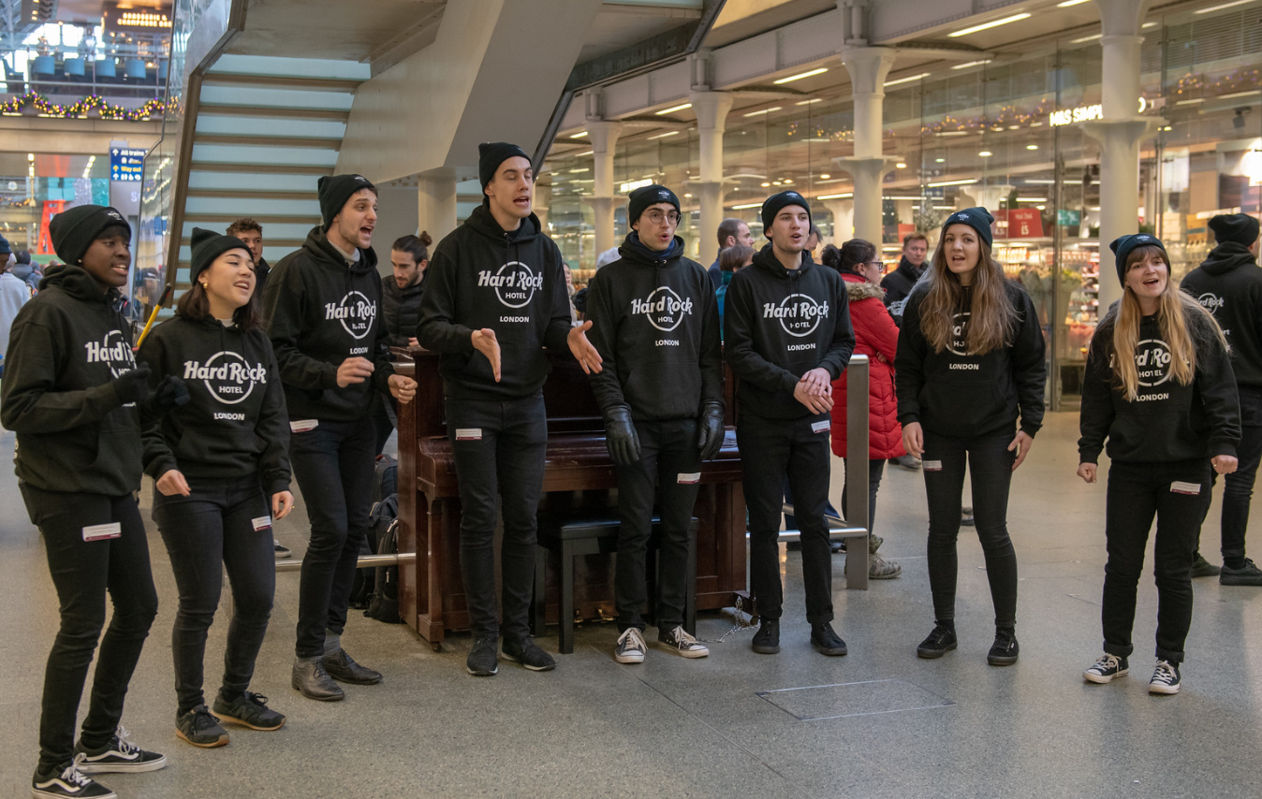
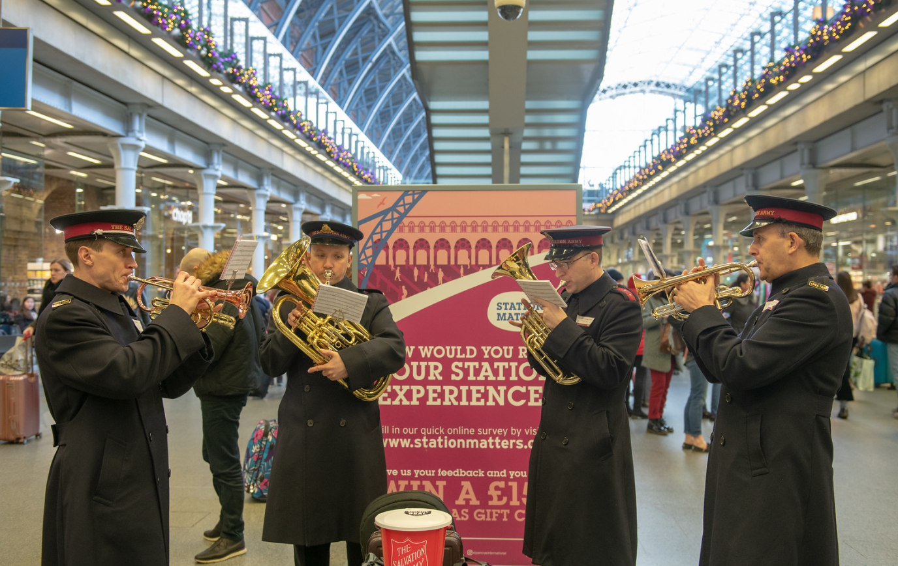

If you would like to apply to perform at the station, we require all choirs and groups to meet with the following criteria:

- For maximum impact, we want choirs to stand out from the crowds by wearing their charity’s branded clothing or matching colours uniform/clothing or even props (examples shown in the pictures above).

- With it being an increasingly cashless society that we live in, and with some concerns on handling cash itself since COVID19, we encourage charities that use contactless technology to collect funds. In previous years, the charities that provided the facility for contactless donations made more money than those using just bucket collections. The station has free Wi-Fi that can be used for this.

To apply for a performance slot at the station, there is a three-part application which must be completed and signed. All documents must be submitted in full, accompanied by your proof of Public Liability Insurance.

Part 1 –Application Form for HS1 Ltd
Part 2 - Music Performance – Terms & Conditions Agreement with HS1 Ltd
Part 3 - Risk Assessment & Method Statement (RAMS) Agreement with Network Rail High Speed

Please submit the documents completed in full and accompanying proof of PLI to: specialevents@highspeed1.co.uk

We will respond as soon as possible to confirm your application and agreed dates and times.

Part 1
Application Form - Carolling For Causes 2022

TO BE COMPLETED IN BLOCK CAPITAL LETTERS
Applicant Name
Applicant Company
Which charity are you raising money for?
(if different to applicant)
Charity Number
Charity Twitter handle
Applicant Address | Postcode:
Applicant Email
Applicant Mobile No.
Public Liability Insurance for Performance  MUST PROVIDE COPY OF CERTFICATE | Start Date |  |  | End Date
Lead Contact Name
(for on the day)
Lead Contact Email
(for on the day)
Lead Contact No.
(for on the day)
How many people will attend to sing?
Please provide full details about the performance
Do you require use of a piano? (max 15 people)
Preferred Performance Date(s) - Between 1st – 24th December 2021
Preferred Performance Time(s)  Please Tick | 7.30am – 9.30am |  | 12pm – 2pm |  | 5pm – 7pm

Sites, dates and times will be allocated to you by HS1 once full details about your proposed performance have been reviewed. Places will be allocated on a first come first serve basis for fully completed applications and we will contact you with alternative details should your preferred slot be filled.

PART 2
St Pancras International Carolling For Causes 2022
HS1 Limited Terms & Conditions

You have recently expressed an interest in performing a musical charity performance (the “Event”) at St Pancras International Station (the “Station”). HS1 Limited (“HS1”) is the registered leaseholder of the Station, and, in consideration of HS1 granting you permission to perform the Event at the Station, you agree to the following terms and conditions set out in below.

    - All details of the Event, including the date and time of the Event, shall be agreed with a representative of Network Rail (High Speed) Limited (the “Station Operator”) prior to the performance of the Event.

    - You shall be responsible for all costs and expenses incurred in performing the Event (including travel expenses, meals, and any other expenses).

    - You shall and shall procure that all persons taking part in the Event (each, a “Participant”), comply with any safety and operational requirements of the Station Operator and/or HS1, including any Risk and Method Statement (RAMS) requirements, and any other requirements as advised by the Station Operator and/or HS1 to you from time to time and so far, as practicable.

    - You shall ensure that each of your Participants observes any instructions of or vacate the Station immediately if they are requested to do so by, (i) HS1; (ii) the Station Operator; or (iii) the British Transport Police, at all times in order that the safety and continued operation of the railway and the Station may be maintained. You acknowledge that HS1 and the Station Operator may be required to close all or part of the Station in an emergency situation.

    - You shall maintain public liability insurance cover of not less than £5 million with a reputable insurer and shall provide HS1 with written confirmation from the relevant insurer that such insurance is in place.

    - You acknowledge that there are no storage facilities at the Station, and that your Participants may not bring any PA equipment, pop-up banners, chairs or any personal belongings to the Station, other than on their person.

    - At the end of the Event, you shall ensure the performance area is clean and tidy.

    - If you are unable to perform the Event at the Station on the date and time allocated to you, neither HS1 nor the Station Operator is obliged to offer you an alternative date and time.

    - HS1 and the Station Operator reserve the right to cancel or change the Event at any time and without notice to you, acting in their sole discretion.

    - HS1 shall not be liable for:
            - any injury or accident-causing loss or damage to a Participant or any third party sustained as a result of a Participant taking part in the Event.
            - any loss or damage sustained by you or any Participants as a result of:
              - the cancellation of the Event by HS1 or the Station Operator for any reason;
              - any changes made to the Event by HS1 or the Station Operator for safety or any other reasons; or
              - any circumstances beyond the control of HS1 or the Station Operator.

These terms and conditions, and any dispute or claim arising out of or in connection with them or their subject matter or formation (including non-contractual disputes or claims) shall be governed by and construed in accordance with the law of England and Wales.

Please sign below to acknowledge your acceptance of the above terms.

Name
Choir/Company

Date

Signature

PART 3
Risk Assessment & Method Statement (RAMS) for Music Performances at Network Rail (High Speed) Stations (including St Pancras International Station)
All risks associated with your event shall need to be assessed, and the necessary controls and mitigations advised to ensure the safety of your personnel, station staff/contractors and our passengers/customers. Risk assessments shall need to be suitable and sufficient to meet the requirements of the Management of Health and Safety at Work Regulations 1999.

These Risks listed are correct for the activity that we agree to allow you to undertake, if you have your own risk assessment, please supply as a separate document. For further guidance on risk assessments, please refer to the HSE website (www.hse.gov.uk).

What are the hazards? | Who could be harmed and how? | What are you going to do to reduce the risks? | What further actions are required? | Action to be taken by whom (name)? | Action to be taken by when (date)?
Complaints about music being played | People walking through the station, TOCS and retailers | Sound levels will be monitored by Network rail | Music kept under 85 decibels | Network rail/  responsible  performer | 1st Dec –24th Dec
Event will include instrumental numbers. Brass instruments being used and a keyboard | Injury to choir,  station passengers, irritations or time lost due to announcement interference | Musical instrument/s to be placed well out of reach of walkways.  Ensure volume is maintained below 85 decibels | Music kept under 85 decibels | Responsible  performer | 1st Dec –24th Dec
Portable Wireless Speaker being used  Sound from speakers disturbing station announcements | Injury to choir,  station passengers, irritations or time lost due to announcement interference | System to be placed well out of reach of walkways  Ensure speaker volume is maintained below 85 decibels | Music kept under 85 decibels | Responsible  performer | 1st Dec –24th Dec
Crowding around performances / photography area | People walking through the station and viewing the performance / waiting or observing, crushing and panic | Passenger flow directed by CSAs and stewards from Network rail where appropriate | Tensa barriers to be used to keep performers separated | Network rail/  responsible  performer | 1st Dec –24th Dec
Arriving to (and leaving from) the station via pedestrian routes. Collision with other pedestrians | Possible personal legal action taken | Trained, competent employees / contractors | Network rail to continue to monitor the effectiveness of existing control measures | Network rail | 1st Dec –24th Dec
Positioning of event items / equipment. Obstruction of pedestrian routes | Slips, trips or falls, possible personal legal action | Trained, competent employees / contractors | Senior employee / contractor to be given a site-specific safety briefing / induction | Network rail | 1st Dec –24th Dec
Security of event items / equipment - theft  Damage | Possible irretrievable loss of items / equipment  Possible damage to irreplaceable items / un-repairable equipment | Trained, competent employees / contractors | Senior employee / contractor to be given a site-specific safety briefing / induction, all items / equipment to be secured at all times | Network rail | 1st Dec –24th Dec
Cordoned off walkways /entrances / exits | Station passengers: could cause time delays to passengers and possible trip/falls could happen due to unexpected cordons | All staff to be briefed prior to event as to where cordons will be placed and signs to direct passengers/guest to correct areas will be placed on cordons | None: Network rail to brief station team fully on areas that need to be cordoned off and put in operation before event starts | Network rail | 1st Dec –24th Dec
Unattended equipment and personal belongings causing tripping or security hazards | Station staff and passengers: time lost through possible security evacuations and bodily injuries caused by trips and falls | All team members to be fully briefed on station security regulations upon arrival. Competent staff on hand to ensure the no items are left by guests at any time | None: Network rail or a responsible performer will enforce supervision at all times to ensure performers and media comply with station regulations | 1st Dec –24th Dec | 1st Dec –24th Dec

- You and your party shall always act in a professional manner whilst at the station. NR(HS) has a zero-tolerance policy for all forms of abuse, both physical and verbal and may take legal action should any of our staff, retailers or contractors make a formal complaint.

- Additionally, St Pancras International Station is a Grade 1 listed building. You shall not be permitted to affix anything (permanent or temporary) to the station fabric without the express permission of High Speed 1, who employs a Historic England advisor – likewise, trestle tables and stands are not permitted at gate line areas due to both heritage and safety considerations. This permission must be obtained, and proof supplied.

By signing this Network Rail (High Speed) Risk Assessment Method Statement, you agree that;
- I hereby confirm, I have read the RAMS and I acknowledge the risks identified.
- I confirm that I, and all the attendees to the site, shall always adhere to the requirements of Part 3.
- I, and all attendees also accept that the event shall be temporarily halted, deferred or cancelled by officials of Network Rail (High Speed) should station operations require it.

Name
Choir/Company

Date

Signature

